REPORT ON THE VİSİT OF PROFESSOR CATALINA BRONSTEIN TO THE PSYCHOANALYTIC CENTER OF CALIFORNIA, April 2-3, 2016

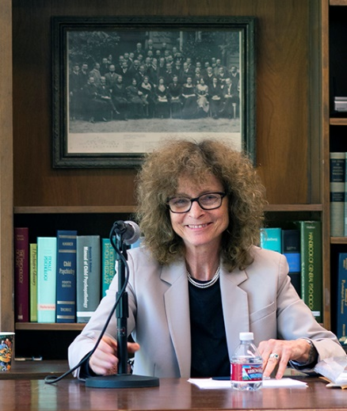
Photo courtesy of PCC member Diane Silverman
The IPA component society, the Psychoanalytic Center of California (PCC), had the pleasure of hosting Professor Catalina Bronstein as the keynote speaker for the 27th Annual Melanie Klein Lecture in Los Angeles. The event involved a pre-conference workshop, an all-day conference on Saturday open to the public, and two clinical case supervisions on Sunday for PCC members and candidates respectively. Continuing education credits were offered for the conference and master classes.
On March 29, 2016, PCC member Dr. Lee Herzog led a two-hour pre-conference workshop entitled, Clinical Theory & Practice of Catalina Bronstein, M.D. Attendees read several of Professor Bronstein’s published papers focused on psychoanalysis with adolescents, in an effort to become familiar with her work in preparation for his visit.
On Saturday, April 2, the all-day program began with Professor Bronstein’s presentation of her paper, Delusion and Reparation: The Analysis of a Psychotic Adolescent.
In this fascinating clinical paper, Dr. Bronstein discussed an adolescent girl's struggle with both external and psychic reality, and her dependence on a delusional system to save her from persecutory voices. Dr. Bronstein proposed that, in some instances, manic reparation and proper reparation can coexist, and that delusions can have a reparative function by providing a sense of integration necessary to prevent total ego fragmentation.

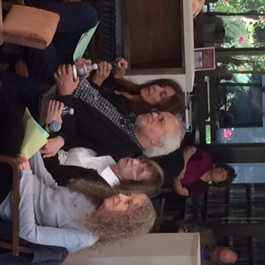

Photo: PCC members Sandra Cohen, Asher Keren-Zvi, Barbara Levin, and Lisa Selin

In the afternoon, Dr. Bronstein presented her paper, The Analyst's Disappointment: An Everyday Struggle. She identified the experience of disappointment as essential for human development and addressed the impact that disappointment has in the clinician's daily work. With the aid of clinical material, Dr. Bronstein explored two different types of disappointment as they are experienced in the transference and countertransference relationship. She went on to discuss the notion of repetition compulsion and the processes of projective identification and counter projective identification that operate in certain cases of impasse where disappointment takes a central place.

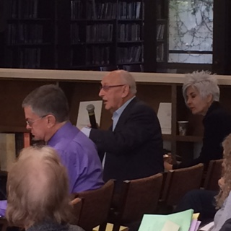

Photo: PCC member Albert Mason asks a question

There were about 90 people who attended the all-day conference, a mixture of psychoanalysts, candidates, students, and other mental health professionals. Following each paper presentation, the audience engaged in a question and answer period moderated by Dr. Jennifer Kunst, chair of the continuing education committee. This was a thoughtful, respectful discussion in which Dr. Bronstein shined in her ability to think sensitively and critically in-the-moment.

On Saturday evening, PCC hosted a dinner in honor of Professor Bronstein with members of the society attending. The evening was filled with delicious food and wine, and lively table conversation.

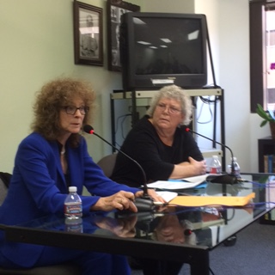
Photo: Dr. Bronstein comments on a case by Dr. Patricia Antin
On Sunday morning, Professor Bronstein conducted a two-hour clinical master class with PCC members, with about 25 members in attendance. Dr. Patricia Antin presented a challenging case of a young adult woman in the early phase of her analysis. On Sunday afternoon, Professor Bronstein worked with an intimate group of 8 candidates, with Dr. David Goldstein presenting one of his control cases. Dr. Bronstein helped create a supportive, thoughtful atmosphere in which many people felt free to participate and share their ideas.
During and after the weekend, the PCC community had the opportunity to reflect on the differences in the clinical work and thinking of a London Kleinian, noting in particular a difference in the emphasis given to early infancy and childhood experiences. In Los Angeles, case conceptualization and interpretations link the transference more readily to the patient’s early history. There is a strong interest in early development, trauma, and primary family relationships in the patient’s infancy. Dr. Bronstein indicated that the patient’s early history is more in the background in her work. In her view, one can only understand the patient’s view and use of his or her early experiences, not what actually happened. She prefers to work at the level of the patient’s internal object world as lived out in the transference. This distinction left us with much food for thought.

The PCC is grateful to the IPA and to CAPSA for supporting Professor Bronstein’s work with us. Please visit our website soon to see the video of the afternoon session at www.p-c-c.org.

Respectfully submitted,
Jennifer Kunst, PhD
Chair, PCC Continuing Education Committee

