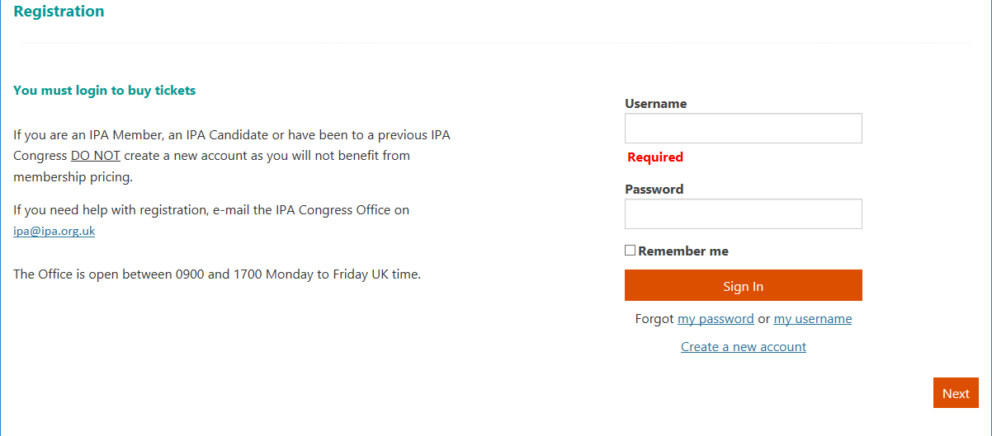
You will be asked to Login. The page contains 3 options.
Use your IPA username and password if you are an IPA member (Allied Centre Member), candidate or have created an IPA account on our website.
If you can’t remember these data, please use ‘forgot my password’ or ‘forgot my username’ and follow instruction on those pages.

Use this link to create a new account, but only if you are not an IPA Member/Allied Center Member, Candidate or non IPA member with previous access to IPA website.

1.Please select ‘yes’ to confirm that you agree with the IPA’s terms and conditions, this is mandatory.
2.Select Save
3.Then click Next to continue
3
2
1
You will be taken to the registration pages where your ticket can be selected. Please note that IPA Allied Centre Members are registered under the IPA Member’s category.
1. Select Register myself
You will automatically see the price that corresponds to your category as IPA member, candidate or non member. If this is not correct please contact our conference team on ipa@ipa.world
US$50 discount will be applied at the checkout

All Pre-congress tickets for Working Groups and Working Parties, International Groups, social events are available by day. To see the list click on the arrow, the programme will open up and you can select the activity you would like to attend.
Gala dinner – you will be able to select the number of tickets you wish to buy; select the number of tickets as required.
When you finish click Next to continue

The following page will show your total, the US$50 discount for completing your registration online will be applied here. To complete the payment please enter your card details and check the address is your billing address. Click Submit Order to complete the transaction

After completing the payment you will receive an email confirmation, using the email address we have recorded in our database.

Thank you

Check the address to make sure it is the billing address for the card you are using
A confirmation email will be sent to the address on our records, if you do not receive the email please check your spam folder and/or contact us on ipa@ipa.org.uk

