Luz Maria Porras
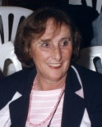
The Board of the Uruguayan Psychoanalytical Association notifies with great sadness the death of our colleague Luz María Porras, which occurred on 8 August 2015.
Luz Porras was President of APU, Director of the Institute and a Full Member who performed training functions.
She was a great psychoanalyst and studious and lover of literature, film and history, which reflected in her various interdisciplinary papers.
We mourn the loss.

